Results of re=5000 for cylinder case.

1. Velocity distribution.

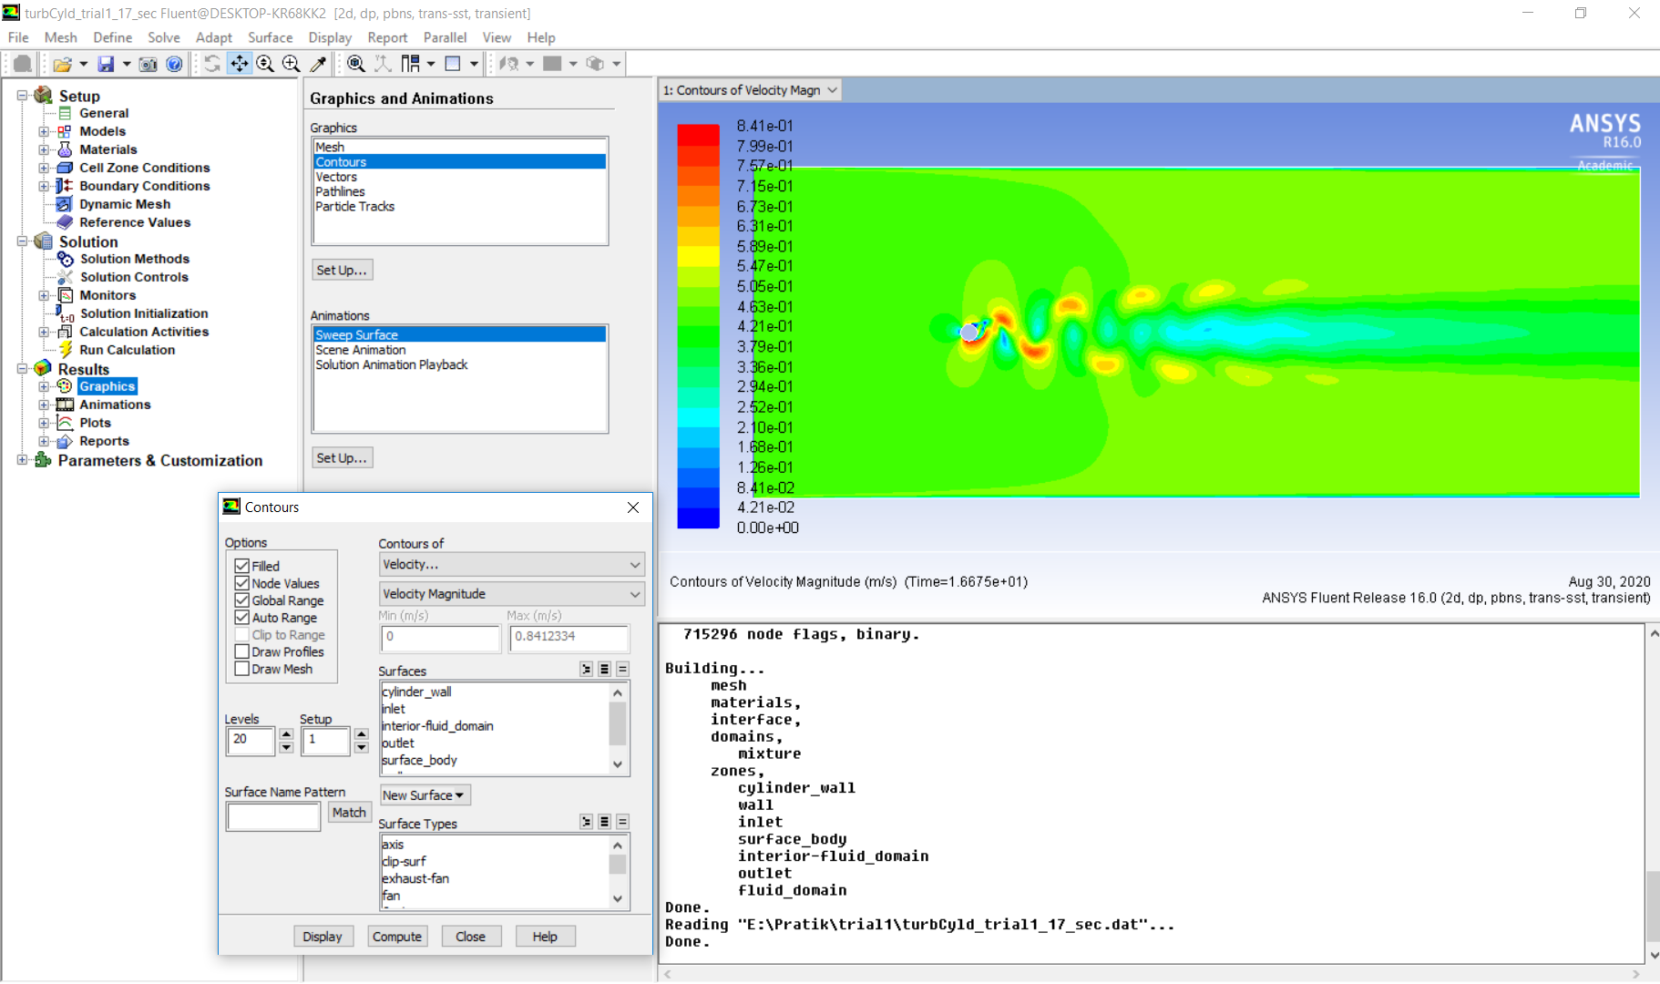

1. TKE distribution

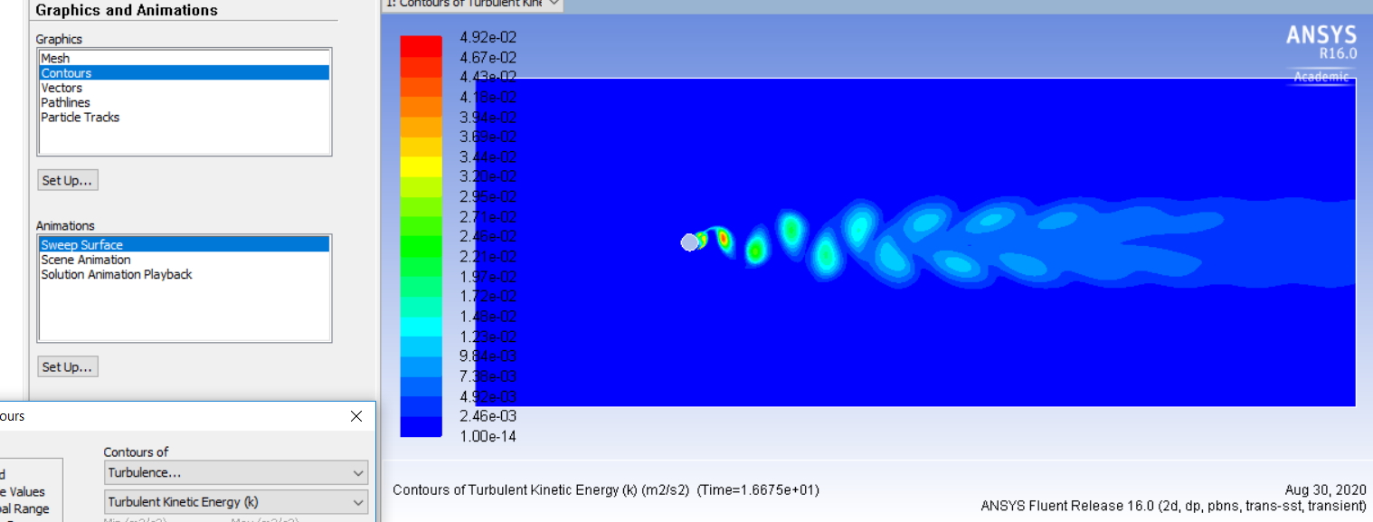

1. Vortex Length calculation

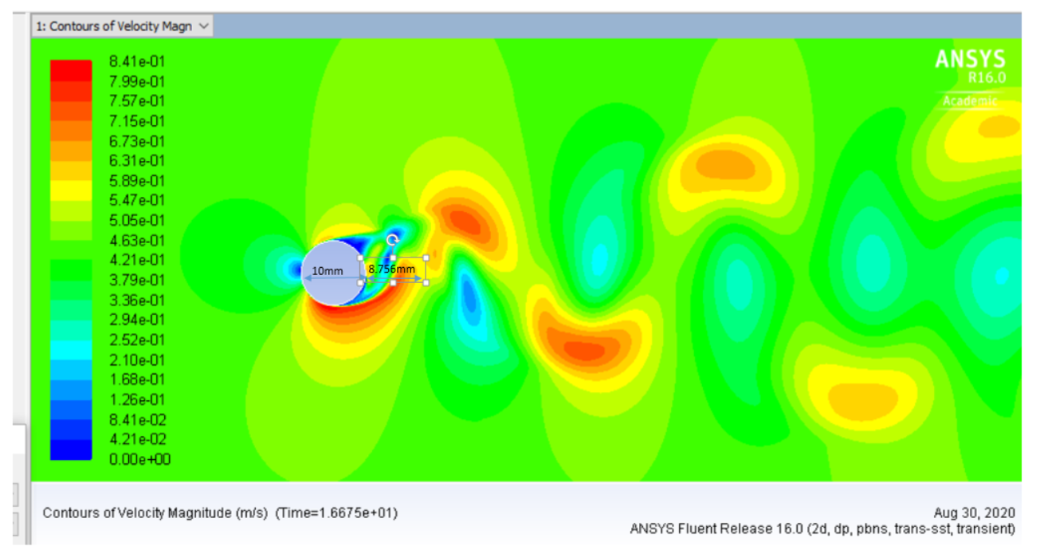

1. Coefficient of Lift plot

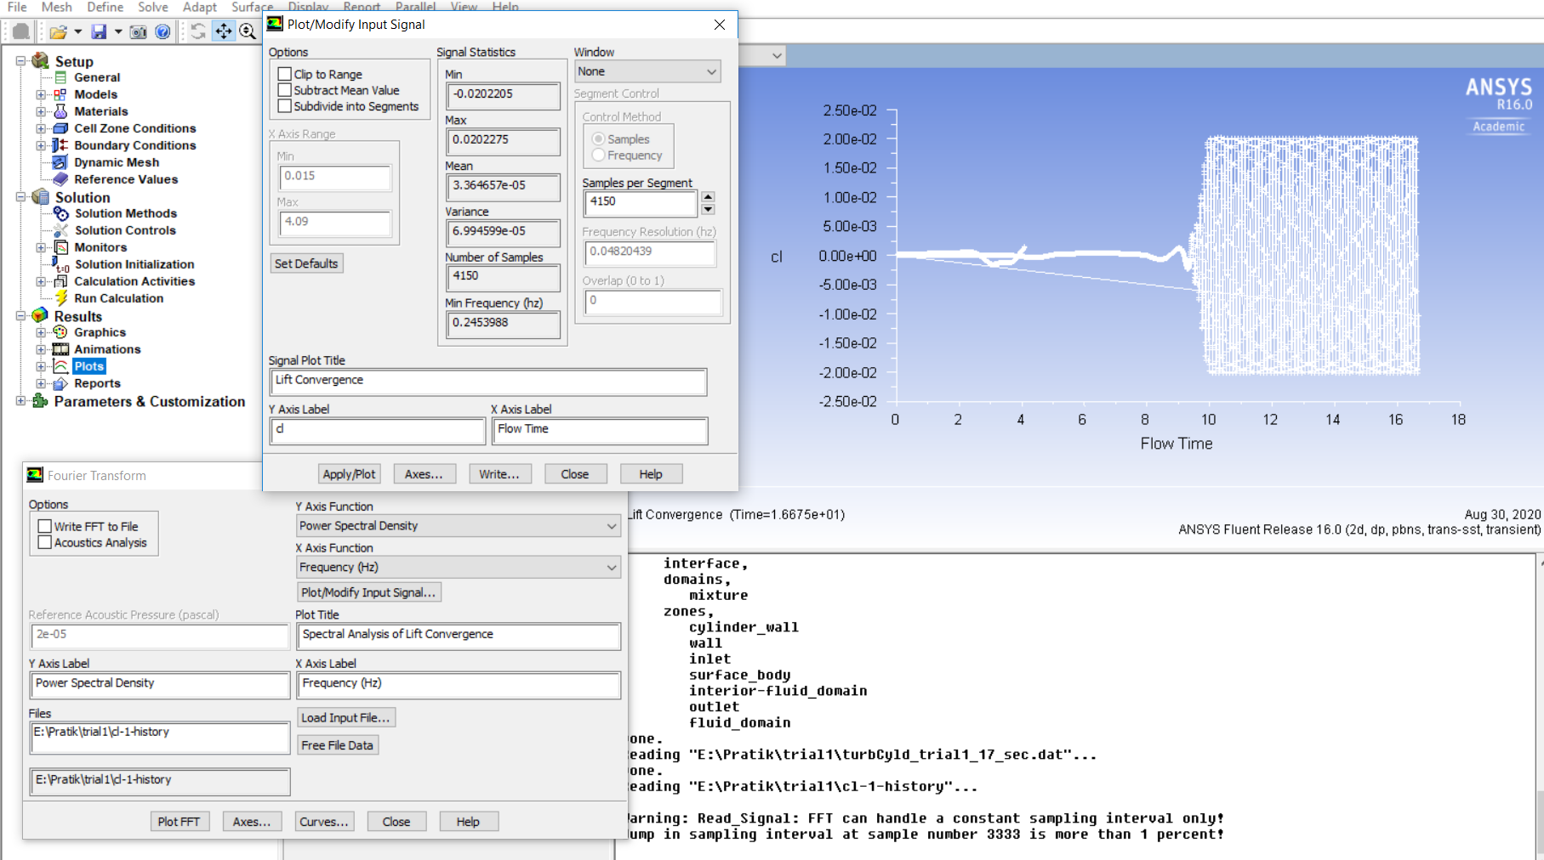

1. FFT and vortex shedding frequency

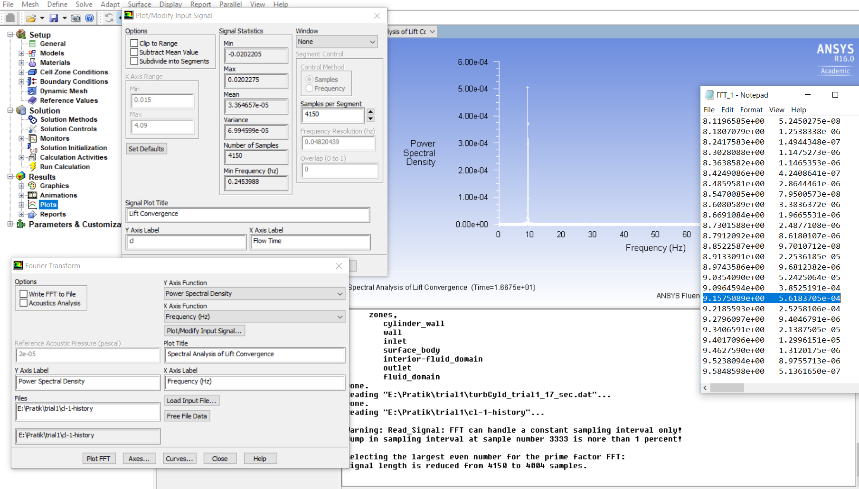

1. Validation of Strouhal frequency with the experimental result in literature.

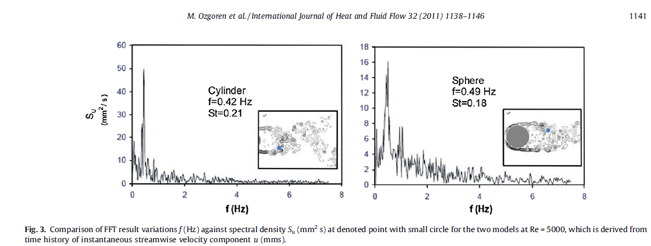

Using the standard formulae for Strouhal Number calculation, St=fL/U, the simulation case yields a St=0.2057 for Re=5000 for cylindrical case (f=9.1575, L=100mm(dia of cylinder), U=0.445m/s). For Re=10000, the simulation is currently running.

For spherical case, the meshing has been done and simulation is yet to be completed.

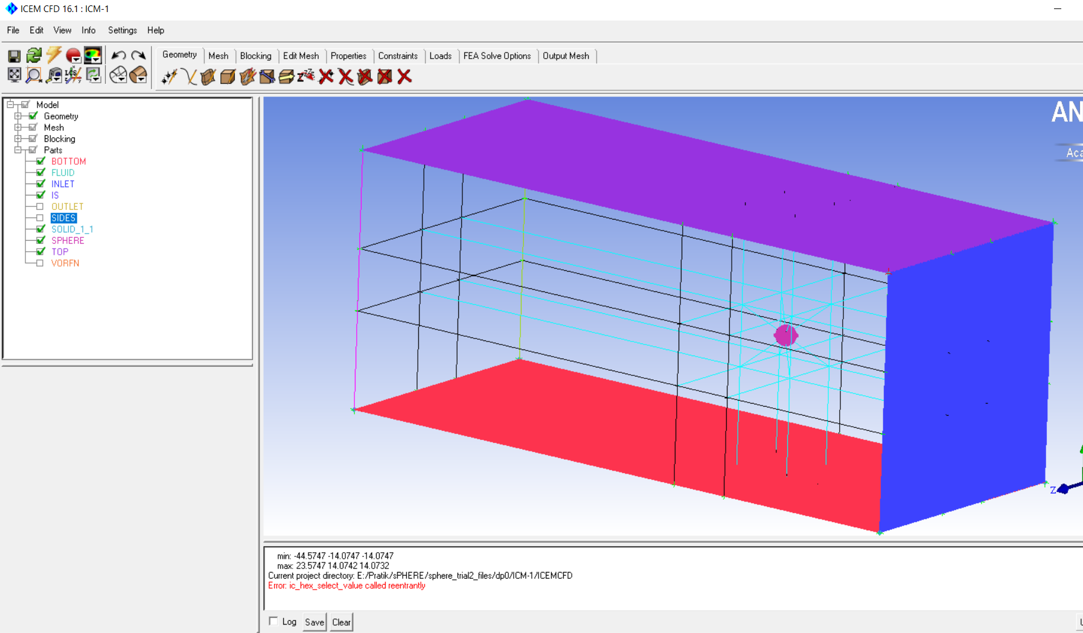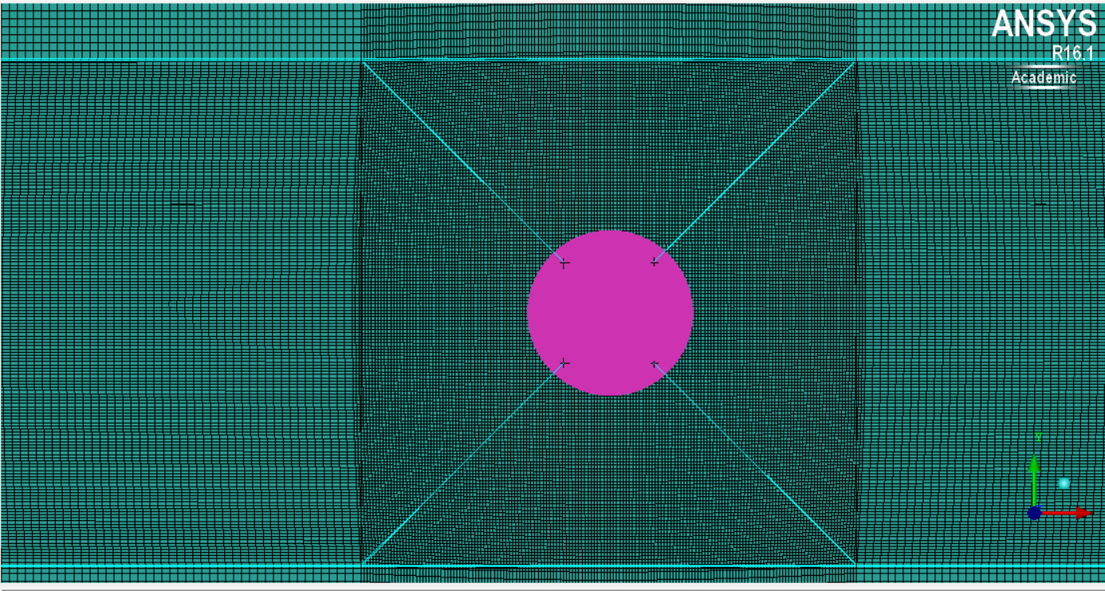

After the simulations, one can then understand the differences in the flow characteristics between two cases.

\*\*Atleast two sets of different blockage ratios may be considered to fulfil the objective of the project and infer the effect of blockage ratio variation.

\*\*\*The files are too large for uploading.